Validators:

Put a validators.required on the roomName element

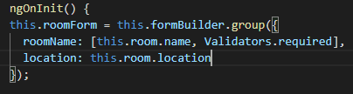

Validate the location as required and having a minmum length of 2

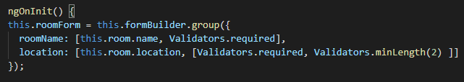

Let us add a console.log() element in the submission() for testing

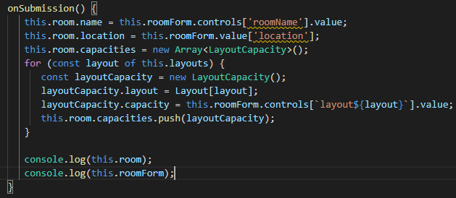

Test the roomName for valid and invalid

Remove the name and save: status: Invalid

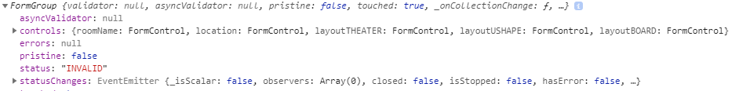

Add a name and save status: Valid

